***Buses Continue East to Park in Lot D***

***E Road to Six Flags***

***Bus Drop Off***

***Participant Entry***

***Parent Entry***

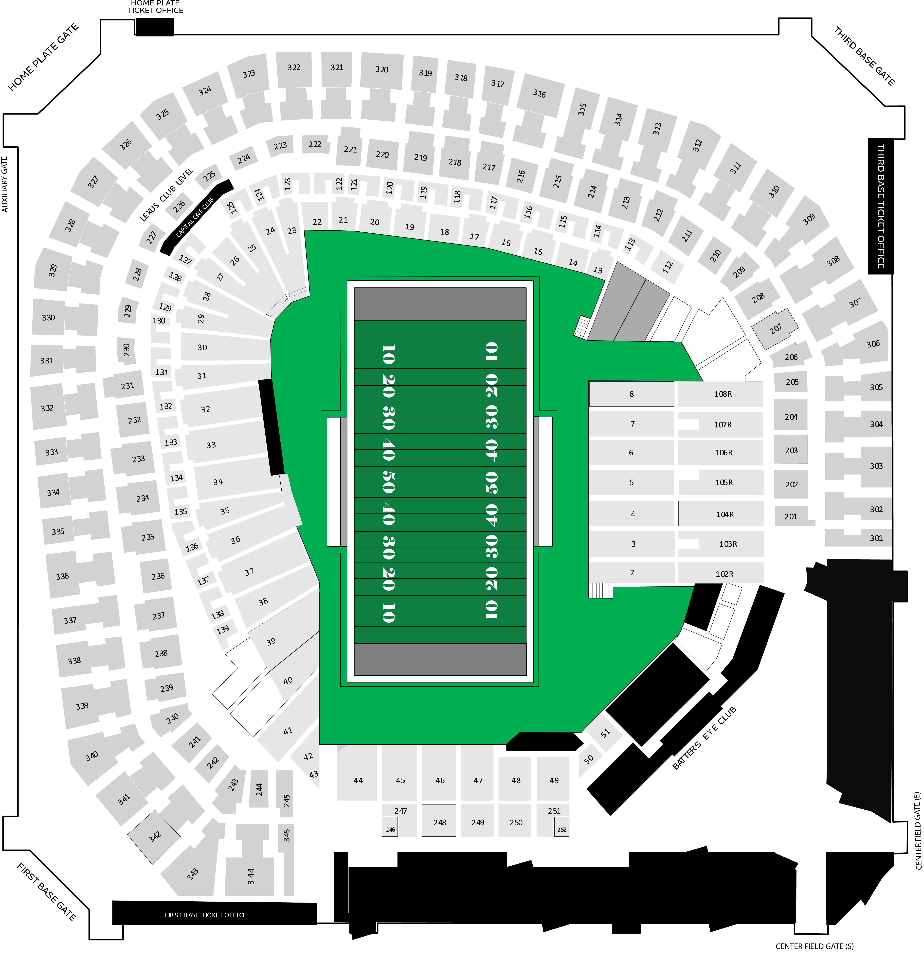

***Ballpark Way***

***Nolan Ryan Expressway***

***CLOSED***

***Randol Mill Road***



