Registering Your Team for State Tournament
Your team has been working all season for your
State Tournament!

- Go to RYT.destinationimagination.org the Sunday after your tournament (you will not be able to register prior to that day) and log in using the same credentials you use to log into the www.destinationimagination.org site.

  - Click on the tournament registration button next to your team name.
  - When you click the link for the Texas -State Tournament Registration, all your information from your regional tournament will transfer over!
  - When you are in the main screen, you will see up to 7 blocks of information that need to be complete.
  - Basic Information: This contains your team name, number and challenge. Please verify that these are correct. If there are errors, please contact your Regional Director.
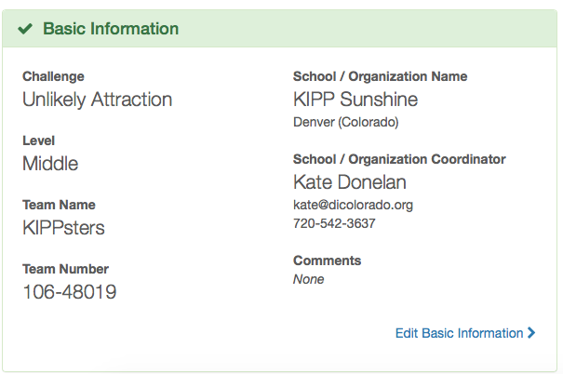

  - Registration Questions: In this block, you will be asked about
    - If you have a member on another team.
    - If you are coaching another team.
    - If you have major scheduling conflicts.
    - List any special accommodations

ALL SCHEDULING REQUESTS MUST BE SUBMITTED TO YOUR REGIONAL DIRECTOR

f. Team Managers: This block is for team managers. In the Team Manager box you will see your personal information and that of any co-managers. Unless there are any changes, click
    - If all the information is correct, click the box that says “this section complete.”
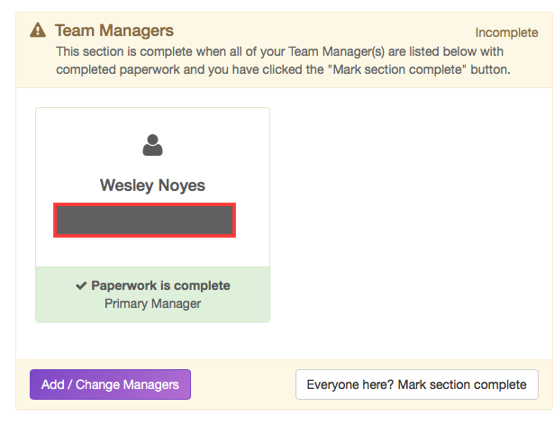
- Team Members: This block is where you will be putting in the information for your team members.
    - If there are no changes to contact information, click the box at the bottom right that says, “this section is complete”
    - All team members must be listed to secure award ceremony complementary wristbands.
    - YOUR TEAM will not be scheduled without this being complete.
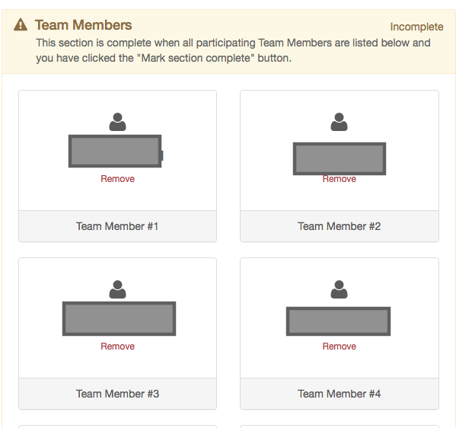

- Team Payment:
    - Mail in a school check- No personal checks accepted and will be returned. (address appears if you select this option) Be aware of your timeline (March 8, 2022)
    - Pay by Purchaser Order (instructions appear if you select this option)
    - Pay with a Credit Card (card info is entered here)
    - There is a button in the upper right of this section where you can view and print an invoice/receipt
    - Visit our website if your district would like to pay using a credit card. There is a separate link on our website.

- CONGRATUALTIONS! YOU ARE REGISTERED!
  - All managers, parents, and appraisers will get confirmation emails when they have been added.

