Good Afternoon Lone Star Finals Team Managers,

We are using a new system this year. Therefore, it is super important you take a moment to check two things (if applicable). I have included the steps below. If you find payment or a school district purchase order is **NOT** listed on your account and it should be, contact me right away (be sure to list all your team info-see below). The Wednesday, March 17, 2021 (tomorrow) is the deadline. All payment/school purchase orders must be applied to your account by midnight on Wednesday, March 17, 2021. If you are turning in a school district P.O. it must arrived to [jarvisj@greenvilleisd.com](mailto:jarvisj@greenvilleisd.com) by noon on Wednesday, March 17, 2021 so I may manually add it. Your registration payment/school district purchase order is required in order to secure your spot of the Lone Star Finals schedule. All unpaid orders will not be filled. The deadline for both registration and purchasing t-shirts/pins is Wednesday, March 17, 2021. Thank you in advance for taking the time to ensure your account is correct so you can be included in the Lone Star Finals schedule.

**Steps to check your account -Lone Star Finals Registration**

**Step 1 Log in** to registeryourteam.org

**Step 2 Click on** **Lone Star Finals 2021 Registration**

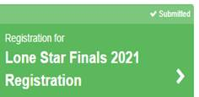

**Step 3 Make sure it shows Submitted** (if payment has not been applied, you will not be allowed to submit)

**Step 4** Scroll down to the button to **View Statement/Receipt**

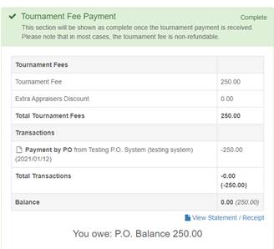

**Step 5 Make sure your fee is paid or a school district purchase order has been applied.**

**Contact me right away with the following information if you find an issue. Please provide the following information when emailing me.**

Team Number 750-

Team Manager Name-

Region-

School District-

School Name-

School Purchase Order Number (if applicable):

School Check Number:

Person who submitted payment:                                       person who submitted payment’s email address:

**Steps to check your Pin and T-shirt Order-Lone Star Finals (if you have a t-shirt or pin order- items are optional)**

**Step 1 Log in** to registeryourteam.org

**Step 2 Click on** **Pin and T-shirt Order Form- Lone Star Finals**

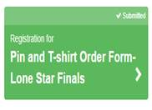

**Step 3 Make sure it reads submitted** – You will need to complete all boxes. Payment must also, be applied in order to submit.

**Step 4** **Scroll to the bottom** of your form to **View Statement/Receipt**

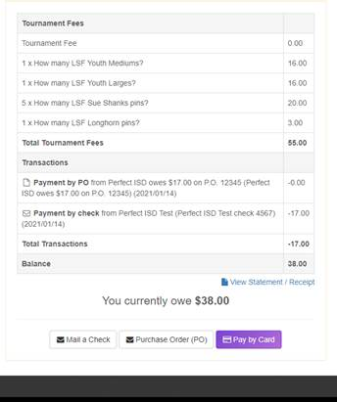

**If you find a payment or school purchase order has not been submitted on your behalf or applied successfully, contact me right away. Please provide the below information when emailing me.**

**Please be mindful of the March 17, 2021 deadline (tomorrow). All unpaid orders will not be filled.**

Team Number 750-

Team Manager Name-

Region-

School District-

School Name-

School Purchase Order Number (if applicable):

School Check Number:

Person who submitted payment:                                       person who submitted payment’s email address

**From:** Jarvis, Jennifer   
**Sent:** Monday, March 15, 2021 4:00 PM  
**To:** Jarvis, Jennifer <[Jarvisj@greenvilleisd.com](mailto:Jarvisj@greenvilleisd.com)>  
**Subject:** Lone Star Finals 2021 Important Deadlines and Updates as of 3/15/2021